Miles Tag™
µMT (Micro MilesTag)
DIY Laser Tag System
_______________________________

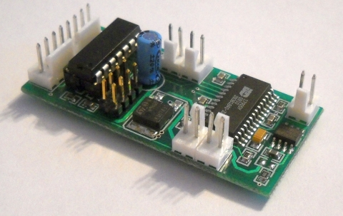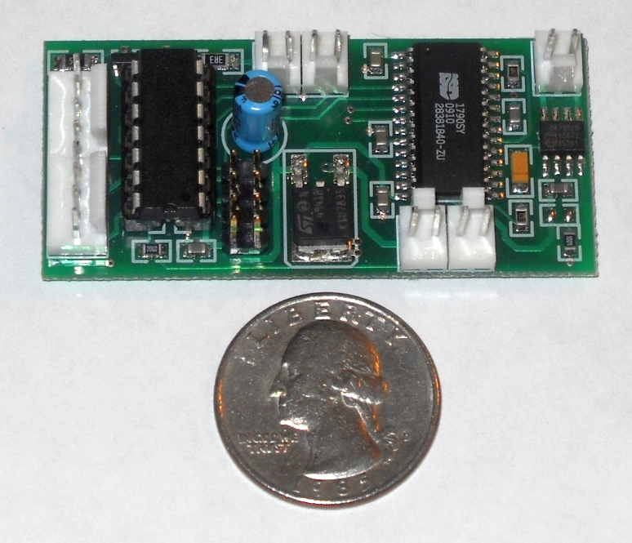

uMT-2016 | Document Revision: 9 Feb 2016

© Copyright 2012-2016, Combat TAG, LLC www.LaserTagParts.com
NOTICE: This document and the systems described herein are protected by international copyright laws. It may not be reproduced in full or in part, for any purpose public or private, without the express written consent of the author. All features, specifications and information detailed in this publication are subject to change without notice. Use of the information and the systems described is entirely at your own risk. The author assumes no liability for injury to persons or damage to property and equipment resulting from the use and or misuse of the information, procedures, circuits and systems described. The author also assumes no liability for typographical errors or omissions.

DISCLAIMER OF WARRANTIES & LIMITATION OF LIABILITY
Combat TAG, LLC makes no warranty, either express or implied with respect to any product or service, and specifically disclaims all other warranties, including, without limitation, warranties for merchantability, non-infringement and fitness for any particular purpose. Combat TAG's sole obligation and liability for product defects shall be, at Combat TAG's option, to replace such defective product or refund to buyer the amount paid by the buyer therefore. In no event shall Combat TAG's liability exceed the buyer's purchase price. The foregoing remedy shall be subject to the buyer's written notification of defect and return of the defective product within ninety (90) days of purchase (date of invoice). The foregoing remedy does not apply to products that have been subjected to misuse (including without limitation static discharge), neglect, accident or modification, or to products that have been soldered or altered during assembly, or are otherwise not capable of being tested, or if damage occurs as a result of the failure of buyer to follow specific instructions. In no event shall Combat TAG be liable to the buyer or to any third party for any indirect, incidental, special, consequential, punitive or exemplary damages (including without limitation lost profits, lost savings, or loss of business opportunity) arising out of or relating to any product or service provided or to be provided by Combat TAG, or the use or inability to use the same, even if Combat TAG has been advised of the possibility of such damages.

“Laser Tag Parts” and “MilesTag™” are alternate business names of Combat TAG, LLC.

www.lasertagparts.com

Specifications:
Input power 7.2 VDC (9VDC max)
IR LED output 1.5 A max (pulsed)
Audio Amplifier .75 W @ 8 ohms (short-circuit and thermal protected)
Audio Input 1 V p-p max (line-level)

PIC16F684 Microcontroller:
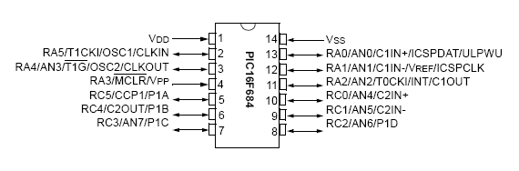

The “brains” of the uMT is a Microchip PIC16F684 microcontroller.
If you have a PIC programmer that supports the PIC16F684, you will be able to update your uMT system in case of future firmware updates. The PIC micro uses FLASH program memory, so it can be reprogrammed thousands of times. When programming, be sure to set the Configuration Fuse settings as shown below or your uMT will not operate correctly.
Here are the recommended PIC16F684 Configuration Settings for the uMT firmware:
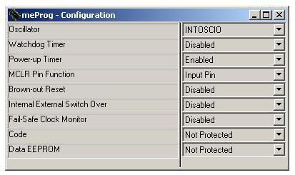
Overview of uMT features:
- Unlimited Players
- 4 Teams
- Enable or disable “same team” hits (friendly fire)
- Digital sound effects
- 1W audio amplifier
- High power IR LED driver (>200 yards range depending on lens setup)
- Sensor “Hit” LED driver
- Trigger and Reload button inputs
- LED “Ammo Counter” Display with adjustable Brightness (optional)
- Free software to upload your custom sound files (Windows)
- Free software to edit gun/game parameters (Windows)
- Compatible with MilesTag CORE V5.6X systems
- Compatible with MilesTag Referee Controller
  - Admin Kill; End Game; Respawn; New Game; Full Ammo; Sensor Test
- Download firmware updates (PIC programmer required)

ADJUSTABLE PARAMETERS
 | DEFAULT | RANGE
FIRING MODE | Full-Auto | Full, Semi, Burst
CYCLIC | 500 RPM | 250 to 800 RPM | Rounds per Minute
ROUNDS / CLIP | 40 | 1 to 250 | Rounds per Clip
CLIPS | 30 | 2 to 200
RELOAD DELAY | 3 | 1 to 30 | Seconds
DAMAGE POINTS | 10 | 1 to 100
HEALTH POINTS | 100 | 1 to 999
HIT DELAY | 1 | 0 to 20 | Seconds
FRIENDLY FIRE | Enable | Enable, Disable | Enable = Same Team Hits allowed
HIT LED ENABLE | Enable | Enable, Disable | Disable = Sensor LED lights on “kill” only
TEAM ID | RED | RED,BLU,YEL,GRN
IR CARRIER | 56 KHz | FIXED
PLAYER ID | 50 | 0 to 49
VOLUME | 0 | 0 to 4 | 0 = Max Volume
BRIGHTNESS | 255 | 0 to 255 | 255 = Brightest
Recommended External Components
QTY |  |  | PART # | SOURCE
1 | Battery Holder | 6 x AA Battery (9V) | BH-6AA | shop.LaserTagParts.com
1 | Trigger Button | Pushbutton, Black | SW-PB-BLK | shop.LaserTagParts.com
1 | Reload Button | Pushbutton, Red | SW-PB-RED | shop.LaserTagParts.com
1 | Speaker | Mylar, pre-wired | SPEAKER | shop.LaserTagParts.com
1 | Infrared LED | Vishay TSAL6100 | IR-LED | shop.LaserTagParts.com
3 | Sensors | Vishay 56KHz | TSOP34856 | shop.LaserTagParts.com
1 | Lens | DCX, 40mm Diameter | LENS-40MM | shop.LaserTagParts.com
2 | Cable, 2C | Power, IR LED | CAB-UMT-PWR | shop.LaserTagParts.com
2 | Cable, 4C | Buttons, Sensor | CAB-4C | shop.LaserTagParts.com

Optional External Components
QTY |  |  | PART # | SOURCE
1 | SLED Display | Serial LED Display, Red | SLED-UMT-RED | shop.LaserTagParts.com
1 | LED Bezel | T1-3/4 Panel Bezel, Black | LED-BEZ | shop.LaserTagParts.com
1 | LED Connector | T1-3/4 Quick Connect | CON-LED | shop.LaserTagParts.com
1 | Serial Connector | 9-pin Female (PC Connection) | CON-DSUB-9F | shop.LaserTagParts.com
1 | Audio Connector | 3.5mm, Stereo | CON-AUD | shop.LaserTagParts.com
1 | Key switch | SPDT, Removable 2 positions | SW-KEY-SM | shop.LaserTagParts.com
1 | Lens Tube | PVC Pipe and fittings |  | Plumbing Supply
PC Board Connections

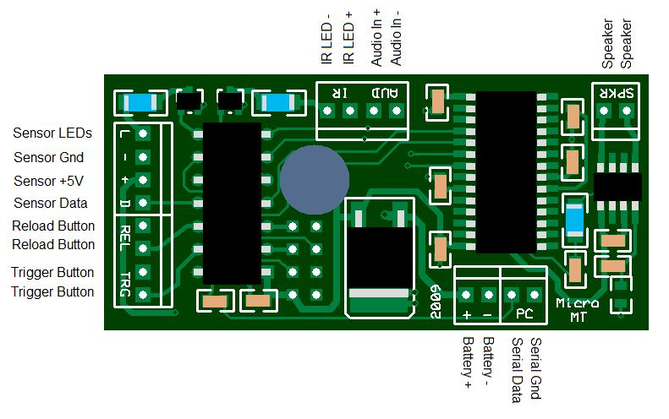

General Wiring Guidelines
Use only stranded hookup wire. Do NOT use “solid-core” wire as it is prone to fatigue and breakage (it is also much more difficult to work with). Stranded core wire is flexible and will be much easier to route to the various parts of your gun. 24ga wire is suitable for most connections, but you may want to use a slightly heavier gauge (i.e. 22ga or 20ga) for connections to the battery and IR LED. This ensures minimal current losses which could reduce the range of the system slightly. The use of wires larger than 20ga is NOT necessary and will only make wiring more difficult.
Keep your wiring neat and orderly. Keep your connections to off-board components short, just long enough to allow easy access to components for maintenance. Do not use excessively long wires that must be “coiled up” or stuffed into the gun casing creating a “rat’s nest”. This will cause problems and make troubleshooting nearly impossible.
Headers
The recommended mating connectors are the Molex KK .100” with locking ramp and ribs. There are also generic versions that are suitable (and may be less expensive).
Battery
Wiring to the battery, power switch, and charging jack (optional) should use minimum 22ga stranded hookup wire. Do not use solid core wire. Install a connector between the battery and the circuit to allow easy battery replacement. Be very careful of polarity when connecting power to the uMT module. Reverse power wiring can cause permanent damage to the module.

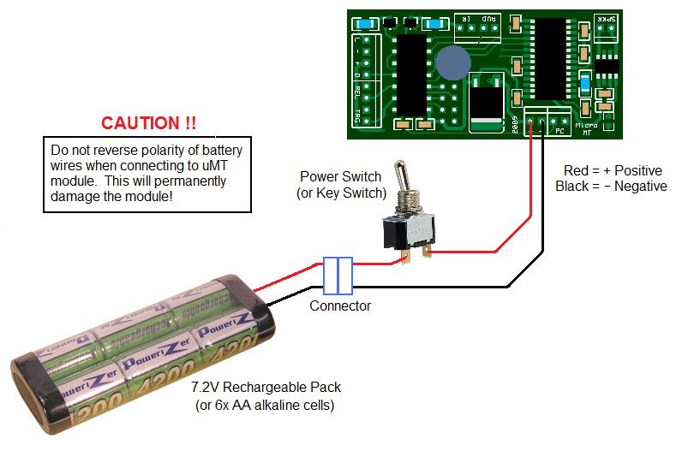
Use a 7.2V NiMH or NiCad battery pack. These are available for RC cars, airsoft guns, etc. Invest in a good quality “smart charger” to extend the life of your battery pack.
You will eventually want to install a charging jack on your gun to eliminate taking the gun apart to access the battery. The diagram below shows how to wire the charging jack. The battery can only be charged while the key switch is in the “off” position. The charging jack is a 2.1mm or 2.5mm DC barrel jack. You will need to install the matching plug on your charger (observe polarity):

Buttons
The Trigger Button and Reload Button are both SPST, Normally-Open, momentary contact. This means that the button is ON when pressed and OFF when released. The voltage and current ratings are not critical, so it’s okay to use miniature pushbuttons or tactile switches.

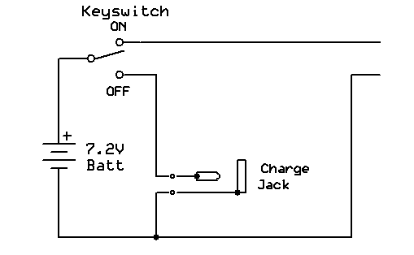
Below is an alternate diagram using a “switched” DC jack to automatically disconnect the battery from the circuit when the charger plug is inserted. This eliminates the need for a power switch (or key switch). You can turn off power to the gun just by inserting a “dummy plug”:
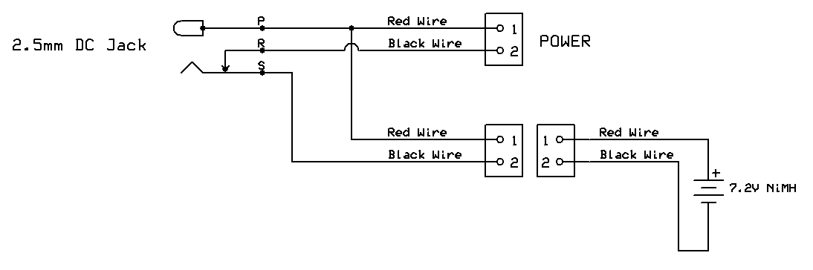
Speaker
Use a small 8-ohm speaker. If the system will be subjected to rain/moisture, look for a speaker with a mylar (clear plastic) cone. The quality and type of speaker used will greatly affect the sound quality and loudness. You may have to experiment with a few different speakers to find one that performs well. Electronic surplus vendors are a good source for speakers. The speaker we sell in the LaserTagParts store is VERY loud.

Infrared LED
The “industry-standard” infrared LED for laser tag is the Vishay TSAL-6100. It is perfectly matched to the Vishay TSOP receivers and can handle significant drive currents (>1.5A) in pulsed operation. The uMT has a built in current limit resistor (3.3 ohm), so you can wire the IR LED directly to the uMT module.

“Muzzle Flash” LED
You can optionally add a super-bright LED to simulate the gun’s “muzzle flash”. It should be connected in parallel with the IR LED. You must install a 100 ohm current limit resistor for this LED (see schematic) as it cannot handle the same high currents as the IR LED.
Audio Input Cable
If you are recording new sound effects to your uMT Module, use the Audio Input Cable to connect the uMT to your PC ‘headphone’ or ‘line’ output. The 10K resistors reduce the audio level and prevent interference between the left and right stereo channels. For stereo sound files, the cable effectively mixes both channels to create a mono signal.
Use a standard 3.5mm stereo jack. (T=Tip, R=Ring, S=Sleeve)

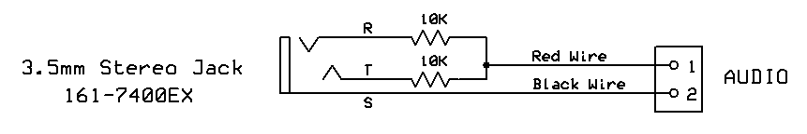

Sensors
The uMT is compatible with 56KHz infrared receivers (Vishay TSOP4856 or equivalent). You can mount the sensors on the tagger, a headband or both. Most people use multiple sensor domes on a headband. Each dome can have 1, 2 or 3 IR receivers installed. If you place multiple receivers in a dome, set them at different angles to create a wider sensitivity pattern.
Basic Sensors: This is the easiest way to wire up the TSOP IR receivers by just wiring them in parallel, and it actually works very well. You can add at least ten TSOP receivers this way. In the drawing below, “V_{s}” is the same as “+5V”, and “OUT” is the same as “Data”.
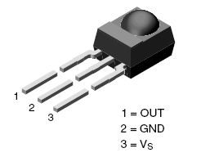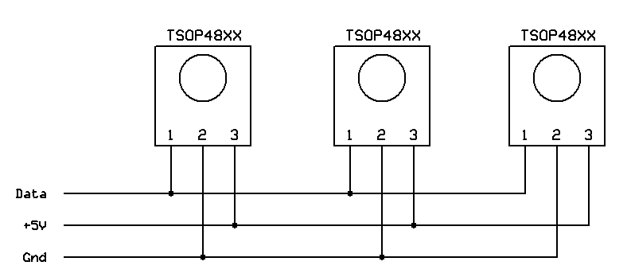

Advanced Sensors (with Hit LEDs): To comply with the Vishay recommendations for the TSOP IR receivers, we should add some power filter components to improve stability of the circuit (the filter simply consists of a 100 ohm resistor and 10uF capacitor). While we’re at it, we can add a super-bright “Hit LED” and current limit resistor to each sensor. The Hit LEDs add a lot of fun to the game, as you can easily see when you are hitting your opponents. This design will equal or outperform the sensors found on many professional outdoor laser tag systems.
Optionally, you can protect your sensors by mounting them inside a small plastic case or dome. Use polycarbonate plastic for the best impact resistance.
NOTE: Hit LEDs will not be visible through IR (black plastic) domes. So you may have to drill a small hole in the dome to mount the LED.

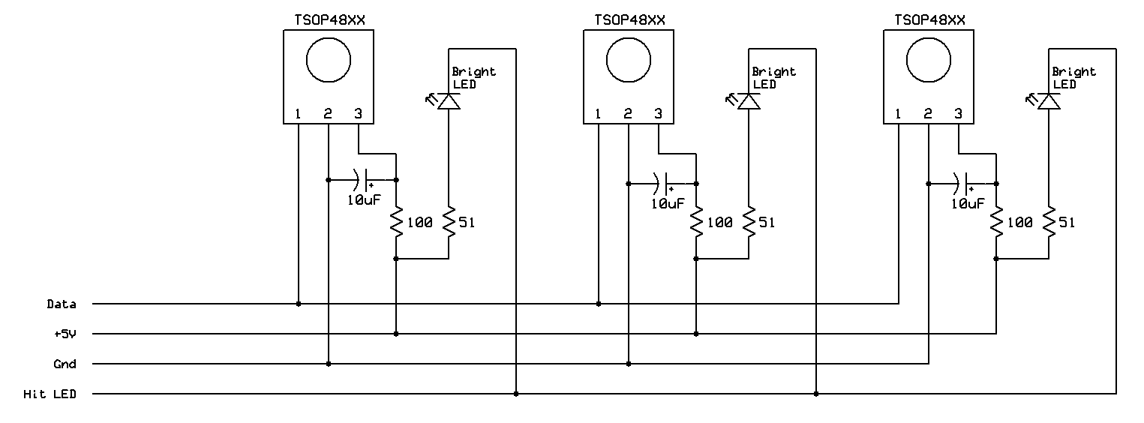

SENSOR COMPONENTS
QTY | DESC | PART # | SUPPLIER
3 | 56KHz IR Receiver, Vishay | TSOP34856
3 | LED, Red Super Bright | TLCR5800
3 | Capacitor, 10uF, electrolytic | 140-XRL16V10-RC | Mouser
3 | Resistor, 100 ohm, 1/8W | 299-100-RC | Mouser
3 | Resistor, 51 ohm, 1/8W | 299-52-RC | Mouser
3 | Sensor PC Board | SEN-PCB
LENS ASSEMBLY
Without a lens, the IR LED will have very short range and a wide transmission angle (like a TV remote). Lenses are available in a variety of diameters and focal lengths. You will need to design your lens tube to match your lens. Usually a suitable lens tube can be constructed using plumbing pipe or electrical conduit and fittings available from any hardware store. PVC pipe is durable and easy to cut to length.
Rule of thumb: A larger diameter lens will capture more of the IR energy emitted from the LED, and a lens with a longer focal length will result in a narrower ‘beam’. As a good starting point, try to find a ‘Dual Convex’ (DCX) lens with a diameter of approx 1.5” to 2” (38mm to 50mm) and a focal length of approx 3” to 6” (75mm to 150mm).
Reality Check: You don’t need high-quality optics. Many lenses available from optical surplus or science/education retailers are perfect for DIY laser tag. I have achieved >200m range using a $1.00 plastic hobby magnifier lens. Don’t worry about minor scratches, chips or imperfections in the lens.

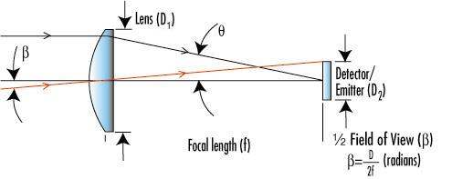

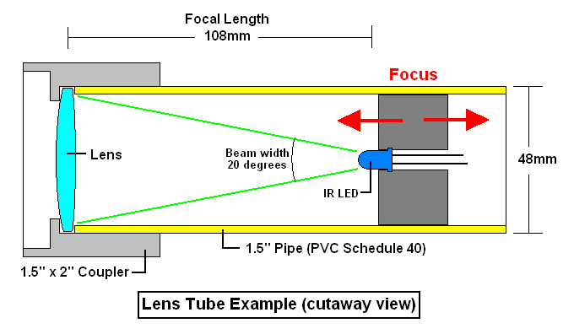
SLED “Ammo Counter” Display
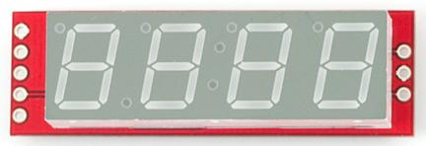 | 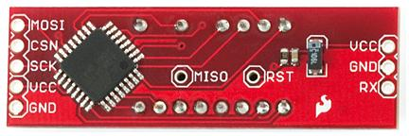
Older Version Display (Front) | Older Version Display (Rear)
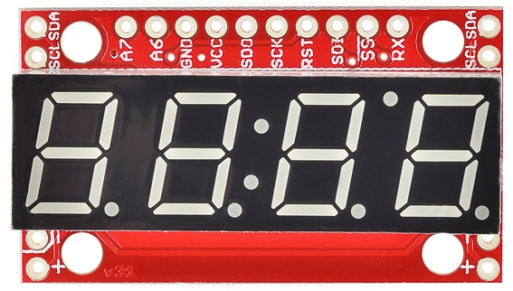 | 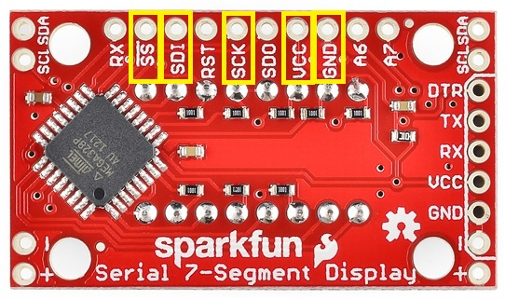
New Version Display (Front) | New Version Display (Rear)

The uMT module supports an optional 4-digit Serial LED display (SLED) available from the Laser Tag Parts Online Store (shop.lasertagparts.com).
Normally the Remaining Rounds in the current “clip” are displayed.
Remaining Clips (C ##) are displayed during Reload. The max display is “99”.
Health Value (H ###) is displayed by pressing and holding the Reload button when the Clip is full.
SLED Connections (SPI)
 | uMT Header | New Display | Older Display | 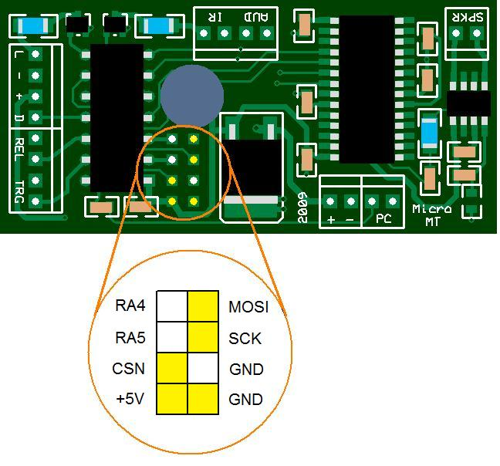
Serial Data | MOSI | SDI | MOSI
Serial Clock | SCK | SCK | SCK
Chip Select | CSN | SS | CSN
5VDC | +5V | VCC | VCC
Ground | GND | GND | GND

PC Configuration Software (Windows XP or Vista)
NOTE: All software is provided as-is. Use at your own risk. Source code was written using the Liberty Basic compiler for Windows.
This software allows you to edit the uMT parameters. Unzip the included files to a folder named “Micro MT Editor”. If your PC does not have a hardware serial port (most new PCs do not) then you will need to use a USB to Serial adapter cable. Do NOT use a TTL Level Converter (MAX232, etc).
- Double click on “uMT Editor 32.exe” to start the application.
- Turn the uMT system OFF.
- Connect a serial cable from the PC to the uMT system (see uMT schematic for wiring).
- Select the appropriate COM Port on the application (your PC may have more than one).
- Turn the uMT ON while holding the TRIGGER.
- The Sensor Hit LEDs will turn on and stay on to indicate the uMT is in “programming mode”.
- Set the parameters as desired.
- Click on “Send To Gun”.
- The Sensor Hit LED will begin flashing rapidly as parameters are saved to the uMT system.
- The uMT will play a sound to indicate success or error.
- Turn the uMT system OFF and disconnect the serial cable.

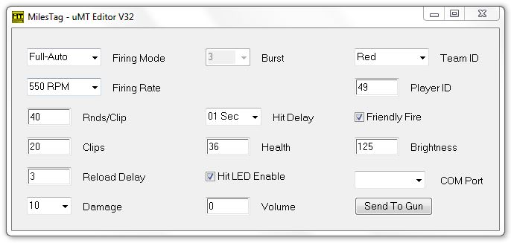
Parameter Ranges
Rounds/Clip 1 to 255 (rounds per clip)
Clips 1 to 200
Reload 1 to 30 (this is the reload delay time in seconds)
Health 1 to 64 (normal set to 36 for 100% health)
Player ID 0 to 50 (recommend only use ID “50”)
Volume 0 to 4 (0 = Loudest)
Brightness 0 to 255 (255 = Brightest)
uMT Sound Programmer (Windows XP or Vista)
NOTE: All software is provided as-is. Use at your own risk. Source code was written using the Liberty Basic compiler for Windows. I can provide the full source code if you are interested in modifying or porting to other compilers/platforms.
The Sound Programmer utility allows you to reprogram the uMT with your own custom sound effects. This software is provided free of charge and as-is. Use it at your own risk. I have no problems on a desktop/laptop PC running Windows 7.
To customize the uMT module with your own sound files (.wav), simply place the new files in the same folder as the Sound Programmer application. The new files must be renamed exactly as the original files, so you should back up the original files before replacing them.
NOTE 1: The overall sound volume and quality are significantly affected by speaker selection.
NOTE 2: There is a maximum length allotted for each sound effect. Make sure any custom sounds do not exceed the maximum length or the end of the sound will be cut off:
NOTE 3: If you are creating your own sound effects, use a sound editor to normalize the volume of all sound effect files. Also trim any silence or unwanted artifacts from the start and end of each sound to prevent delays during playback.

SOUND | NAME | FUNCTION | FILE NAME | MAX LENGTH
Sound 01 | Shot | Gun Firing | 01_shot_umt.wav | 1.5 second
Sound 02 | Empty | Hammer Click | 02_empty_umt.wav | 1 second
Sound 03 | Clip Out | Start Reload | 03_clip_umt.wav | 1 seconds
Sound 04 | Action | End Reload | 04_action_umt.wav | 1.5 seconds
Sound 05 | Near Miss | Near Miss | 05_miss_umt.wav | 1.5 seconds
Sound 06 | Damage | Hit | 06_hit_umt.wav | 2 seconds
Sound 07 | Kill | Kill | 07_kill_umt.wav | 3 seconds
Sound 08 | Power Up | Power Up | 08_power_umt.wav | 4 seconds
Sound 09 | Beep | Okay | 09_beep_umt.wav | 1 seconds
Sound 10 | Buzz | Error | 10_buzz_umt.wav | 1 seconds
Sound 11 | Medic | Receive Health | 11_medic_umt.wav | 1.5 seconds
Sound 12 | Game Over | Game Over | 12_gameover_umt.wav | 1.5 seconds
Sound 13 | Critical | Low Health | 13_critical_umt.wav | 1.5 seconds
Sound 14 | Beep 2 | Beep 2 | 14_beep2_umt.wav | 1.5 seconds
Sound 15 | Disarm | No Ammo | 15_disarm_umt.wav | 1.5 seconds

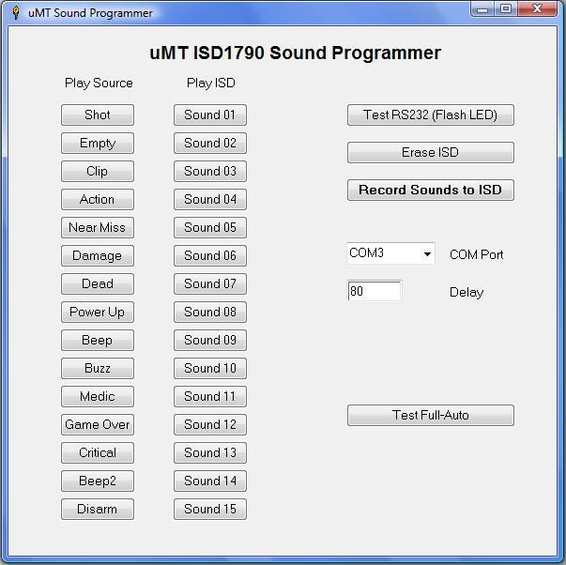

Play Source – Click any button in this list (Sound 01 to Sound 15) to hear the original wav file played from the computer. When you connect the PC’s audio output (line or headphone) to the uMT Audio Input, you will hear the sound through the uMT module’s amplifier and speaker. This allows a true A/B comparison of the original vs. recorded sound quality.

Play ISD – Click any button in this list (Sound 01 to Sound 15) to play back the recorded sound from the uMT module’s sound chip. If the sound is distorted, then you should decrease the volume from your PC. If the sound is too weak, then you should increase the volume from your PC.

Test RS232 (Flash LED) - Click this button to test the serial connection from PC to uMT module. The Sensor LED will flash once if the connection is good. If it does not work, check the cable and the COM Port settings (9600 baud, 8N1). If you are using a USB to serial adapter, make sure you have the latest drivers installed.

Erase ISD - Click this button to erase ALL sound effects from the uMT module. This should be done prior to recording.

Record Sounds to ISD - Click this button to begin recording ALL sounds to ISD. Wait until all 15 sounds have recorded before doing any other actions. You should hear the sounds from the uMT speaker as they are being recorded.

COM Port - Select the COM Port for serial communications. This should be a dedicated serial port, or a USB to serial adapter.

Delay - The default Delay setting is 80 milliseconds. If the module appears to cut off the beginning portion of each sound, then you should increase the delay setting. If the Sound Programmer appears to insert a short silence (delay) at the beginning of each sound, then you should decrease the delay setting.

Test Full-Auto - Click this button to play “Sound 01” (firing sound) in a rapid-fire sequence. This allows you to hear what the uMT will sound like when firing in Full-Auto mode. If the firing sound is inaudible during rapid fire, or it is “stuttering”, you may want to re-record the sounds and/or adjust the DELAY value.

RECORDER OPERATION

NOTE: A special RECORD CHIP is used for programming sounds into the uMT. This is a PIC16F684 with firmware for interfacing with the Recording Software application. The firmware for the RECORD CHIP is available for download.
- Make sure the uMT module is fully connected and Power is OFF.
- Install the RECORD CHIP (PIC16F684 with Recording Firmware) to the uMT module.
  - The Recorder Firmware is required for recording sounds.
  - The recorder will NOT work with the uMT Firmware.
- Connect audio cable from PC to uMT module.
- Start Sound Programmer Application.
- Select COM Port.
- Turn uMT module ON, watch for Sensor LED to flash.
- Connect Serial cable from PC to uMT module.
- Click on the Test RS232 button, watch for Sensor LED to flash.
- If Sensor LED did not flash, change COM Port.
- Click on Erase ISD, watch for Sensor LED to flash.
- Click on Record Sounds to ISD, Sensor LED will light during recording.
- After recording completes, use the Play ISD buttons to review sounds.
- Use the Test Full Auto to see if Sound01 is able to retrigger for rapid fire.
- If there are any problems, just click “Erase ISD” and record again.
- It is not unusual to require 2-3 attempts to get a good recording.
- If recording is okay, turn off uMT power.
- Disconnect Serial Cable and Audio Cable.
- Remove the RECOPRD CHIP and install the PIC16F684 with uMT Firmware.
- Turn the uMT ON and test operation.

TIPS & RESOURCES
∆ Use a good quality ESD-safe soldering iron and solder intended for electronics PCB assembly.

∆ Use proper ESD handling procedures for sensitive components.

∆ Do not overheat components or connections during soldering.

∆ Use stranded core ‘hook-up’ wire for off-board connections. Do NOT use solid core wire.
Battery wiring: 22ga
IR LED wiring: 22ga
Button wiring: 24-26ga
All other: 24ga
Telephone extension wire (4 conductor stranded-core) works well for sensors.

Online Forum: www.LaserTagParts.com/forum

Firmware, Parts, Info: www.LaserTagParts.com

